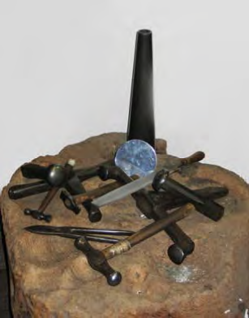The photograph below shows a: ﬁle; planishing hammers; planishing stakes; raising hammers; raising stakes; shears; triblet / mandrel. They are siƫng on a blocking stump.
Step 4 ‐ Planishing – the ﬁnishing technique to smooth the surface of the object aŌer raising it. The object is placed over a planishing stake and hammered using a planishing hammer, which has a ﬂat surface

The Techniques

Again, as with the tools, the techniques to make an object have not changed. They have stood the test of Ɵme and are used by modern‐day silversmiths not only in the Workshop but also around the world.

Step 1 – Cuƫng out ‐ all objects or parts of objects are cut out from a ﬂat piece of silver using shears. Using a
compass or dividers, the dimensions are either marked directly onto a ﬂat piece of silver, or, in the case of spherical/cylindrical objects, transferred from the drawing to a template and the template placed on the silver before cuƫng out is done.

Step 2‐ Forming – the ﬁrst stage in creaƟng the shape of the object. For round objects, e.g. sugar bowl, the piece of silver is placed on a blocking stump, i.e. a wooden block of wood, which has diﬀerent sized hollows. For spherical/ cylindrical objects, the silver sheet is bent round a triblet/ mandrel manually, using a mallet when necessary.

Step 3 ‐ Raising ‐ hammering the object to create a shape;
a raising hammer has a rounded surface.
Step 5 ‐ Annealing – this is heaƟng the object, using a blow torch, to make it more ducƟle, i.e. workable, when raising or planishing. The silversmith uses this technique, alternaƟvely, when raising or planishing unƟl the desired ﬁnish is achieved.

Step 6 ‐ Soldering, ﬂuxing and pickling – soldering and ﬂuxing is joining two pieces of silver, or two edges, together by melƟng a sƟck of silver solder, so that it is free‐ﬂowing. The ﬂux, normally borax, is chosen to match the silver solder and facilitates the soldering process. Immediately the soldering has ﬁnished, the object is pickled, i.e. plunged into a weak acid soluƟon, to cool it and to remove oxidaƟon marks.

Step 7—OrnamentaƟon—there are two methods of ornamentaƟon: repoussé, which is hammering on the reverse to create ornamentaƟon or a design in low relief; chasing, which is the opposite of repoussé and is hammering on the front to reﬁne a design.

Step 8 ‐ Clean, ﬁle and polish – any rough edges are ﬁled before the whole object is cleaned and polished using
the wet and dry method and an emery cloth.

Step 9 ‐ Assay – the ﬁnished object is sent to an Assay Oﬃce where a scraping is taken from each component part to test for purity; providing the tesƟng is successful, the appropriate stamps are added, see below.

Step 10 – Clean and polish – on its return from the Assay Oﬃce, the object is given a ﬁnal clean and polish using brushes and mops on the electric polisher to create a clean, bright ﬁnish.

Hart Silversmiths Trust

Inspire I Conserve I Educate

Historical Drawings
Conservation Project

Conservation & Traditional Silversmithing

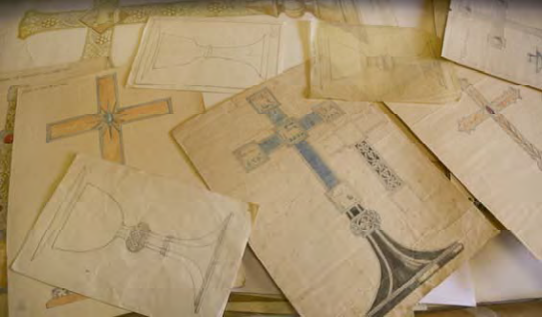

A registered charity reference number XT27245

What is the Hart Silversmiths Trust Historical
Drawings ConservaƟon Project?

The Trust’s Vision

There are some 3000+ original drawings and designs, mostly done by George Henry Hart, which have been donated to the Hart Silversmiths Trust for safekeeping and which are in need of conservaƟon.

The Project began in June 2012 and will run for three years. It is supported by a range of people including: volunteers; experts in document conservaƟon; educaƟon professionals.

The Trust’s vision is encapsulated by ICE, to:

♦ inspire those who wish to ﬁnd their creaƟve spirit through designing and working with metal
♦ conserve the original drawings and designs as part of the arts and craŌs heritage
♦ educate— providing informaƟon and an historical and a social background through establishing a digital archive

ConservaƟon

The collecƟon will be conserved through storing the drawings in acid‐free folders and boxes and archiving them in an environment that is appropriately con‐ trolled with respect to temperature and humidity. Prior to archiving, there are a number of steps that are
being taken. They include:

♦ cleaning, where appropriate ‐ either basic cleaning, done by trained volunteers, or higher level cleaning undertaken by a professional conservator
♦ cataloguing—using a formal, museum‐
orientated method
♦ scanning—each drawing will be scanned and the images loaded onto a database

Basic cleaning
The main objecƟve with basic cleaning is to remove the
top ﬁlm of dust and grime using specialist conservaƟon cleaning tools and materials. At December 2013, around
650 drawings have been cleaned by trained volunteers using a ﬁne, white powder and goat‐hair brushes.

A small amount of powder is sprinkled onto the drawing and gently brushed over it. This acƟon allows the powder to absorb the dust and grime without aﬀecƟng the drawing. The powder gradually turns grey and then almost black, which indicates that the dust and grime is being removed, see the photograph below

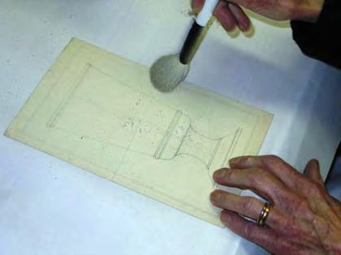

A volunteer from the Blockley arm of the NaƟonal AssociaƟon of DecoraƟve & Fine Arts SocieƟes cleaning a drawing

InspiraƟon & EducaƟon

The Trust is working with university professionals to provide opportuniƟes:
♦ at universiƟes, for researchers and students studying the history of art and looking at a curatorial career
♦ at schools and colleges for students at all levels and of all ages, to give them an understanding of
tradiƟonal ways of designing and working with metal
♦ to the public at large, providing informaƟon about the Arts & CraŌs Movement and encouraging and
enthusing anyone interested in designing and the craŌ of silversmithing
TradiƟonal Silversmithing ‐ The Design, Tools and Techniques

The design

Apart from making objects, George Hart spent many hours designing. Having been given a commission, his ﬁrst step was to draw the object using a combinaƟon of freehand, a compass and other draŌing tools. All drawings were done life‐size so that the amount of materials needed was easily worked out. In some cases, especially when precious stones were part of the object or when it required signiﬁcant ornamentaƟon through chasing and repoussé work (see below for deﬁniƟons), a colour wash was added.

ConsulƟng with the customer, adjustments would be made to the original drawing, e.g. the size and decoraƟon, and, when necessary, further drawings produced to give opƟons.

SomeƟmes, as the making of the object progressed, there might be further, small, changes to the design, which meant that once the object was ﬁnished, it wasn’t exactly as the original design. These changes were due to the customer having another idea about the look or George ﬁnding that it was necessary to make an adjustment from a pracƟcal perspecƟve.

Templates
When the object or part of an object is spherical or cylindrical, for example the bowl and spout for a tea pot, the shape and dimensions for each component part are transferred to separate templates, usually made from cardboard. The templates are then placed on the ﬂat piece of silver for cuƫng out. Otherwise the shape and dimensions are transferred directly onto the piece of silver.

The Tools

The tools used today at the Workshop are exactly the same tools that George used, liƩle has changed. The one signiﬁcant piece of equipment added in the last 50 years is the electric polisher. Prior to this piece of kit being available, polishing was done manually.

